SEO Strategies to Increase Website Traffic

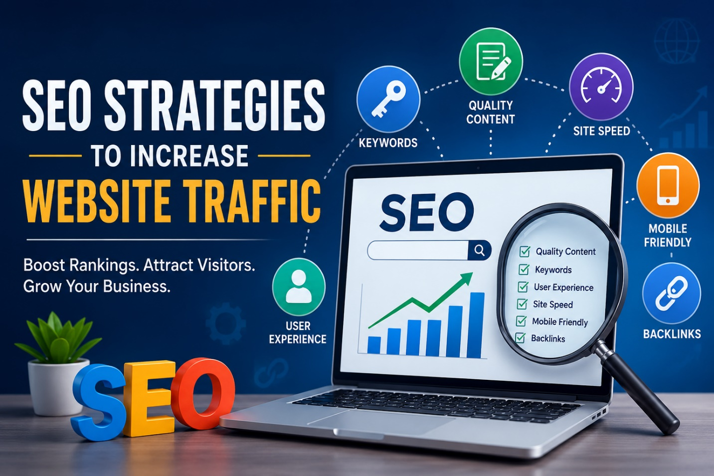
Every company wants website visitors; however, it can be very challenging to get visitors to a website simply by creating it and expecting people to find their way there. With millions of sites on the web today, people are usually more inclined to click on some of the first three search results in Google, which is why Search Engine Optimization (SEO) has become a very important factor in today's digital marketing.
SEO (Search Engine Optimisation) is the process of making a website more appealing to major search engines like Google so as to increase its position in search results and give the site more opportunities for people to discover it at no cost on an ongoing basis.
The majority of people incorrectly assume that SEO is just about adding keywords to a website, but there is so much more involved in successful SEO. In terms of successful SEO, the most critical thing is providing visitors to your website with an experience that is in compliance with the guidelines set forth by search engines to ensure that your content is accurately indexed by search engines.

Understanding Search Intent
Search intent is one of the first things to diagnose when determining how to optimize your website's content for SEO purposes. Before creating informative content, you want to research what kind of information your potential customers are searching for on the internet.
For example, someone who wants to learn about digital marketing skills might search for a Digital Marketing Course in Bangalore instead of just generally searching for marketing classes. By understanding the way people typically search for information, you can create content that aligns with the way people are actually searching for that information.
Therefore, if you have relevant content and the user searches for the same thing you have created, your content is far more likely to rank higher on Google.

The Importance of Quality Content
The majority of content matters greatly for the success of your Search Engine Optimization (SEO) efforts. Your website will perform much better over time if it offers search engines (and users) high-quality, unique material that is useful, informative, and relevant.
Instead of simply creating content for the purpose of obtaining rankings and search engine positioning, you should be developing content to assist others by providing them with the best possible information. Examples include blogs, FAQ pages, guides, tutorials, and helpful resources.
When people find websites that offer high-quality content and can read that content for an extended period of time, the search engines will recognize that the users are staying on the site, and this will earn an SEO boost.
Good content is important for both your users and their search engines.

Using Keywords in a Natural Way
There is still some value to using keywords in the optimization of content, but the method of doing so has been modified over the years. Many years ago, when creating SEO content, many people would stuff as many keywords as possible into an article.
Since search engines and the overall Internet have advanced significantly in many aspects over the last several years, it has become much easier for search engines to determine context as well as classify user intent and the type of content they are searching for.
As a result, keywords should be placed naturally within the content as opposed to seeming as if they have been artificially inserted into the material. If readers can notice or observe that too many keywords have been used throughout an article and the content sounds too robotic due to how it was written, they will usually quickly leave that site.
When writing to achieve SEO results, you should always keep in mind that you want to create content for a human audience first and for an optimized (for search engines) audience last.

The Impact of Website Speed
No one wants to wait for a slow website to download. In fact, most visitors will simply leave a site that is taking too long to load.
Google takes the speed of a website into consideration as an important ranking factor. Websites that load faster generally provide their visitors with a more enjoyable experience, so they perform better in the search engine rankings.
Optimizing images, reducing unnecessary plugins, and using a clean website design are all ways to greatly improve the loading speed of your website.
A fast website will not only improve your rankings, but it will also encourage visitors to stay on your site longer.

The Importance of Mobile-Friendly Websites
Currently, the majority of internet users access the web from their mobile devices instead of a desktop computer, so mobile optimization has become a key component of SEO.
If your website doesn't look good and is hard to use on mobile devices, you can expect users to leave it very quickly, and search engines will also take note of this behaviour.
A mobile-friendly website should:
- Properly load on all screen sizes
- Be easy to navigate
- Have readable text
- Not have a cluttered layout
- Load quickly on mobile network connections

A good mobile experience will directly contribute to both user satisfaction and search engine rankings.

Internal Linking Assists Users and Search Engine Optimisation (SEO)
Internal links are one of the most poorly understood strategies for SEO. All it means is linking together pages within your own domain.
For instance, if you have a blog that talks about social media strategies, there may be opportunities to link to articles about search engine optimisation (SEO) or content marketing, which are also available on your site.
The use of internal links gives users a way to discover additional content, and at the same time assists search engines in understanding the layout of your site much more clearly.
The benefits of internal linking are: better site navigation, an increased number of page views, and users will stay on your site longer while they are there.

The Importance of Backlinks
Backlinks to your site come from links to other sites. Search Engines typically view backlinks as an indicator of trustworthiness or validity (assured credibility).
When reputable sources reference, give backlinks, or mention your content, this indicates to search engines that you are trustworthy and provide value with your content.
Again, quality, not quantity of backlinks, makes the difference. A handful of quality backlinks is far more valuable than one hundred backlinks with little to no trust value.
As long as you produce content of value, provide insight to your industry, publish case studies, and write guest articles, there are many opportunities for businesses to build backlinks naturally.

User Experience Is a Factor in Search Engine Optimization
Search Engine Optimization (SEO) has shifted away from purely being based on technical optimization to also placing significant importance on the end user's experience.
Search engines notice visitors who arrive at a website and quickly leave due to other factors (like bad design, difficult-to-read content, etc.)
Generally speaking, websites that have a good user experience will rank higher than those that do not.
A good user experience consists of the following:
Clear headings
Simple Navigation
Fast Loading
Helpful Content
Mobile Optimization
Proper Formatting
Websites that are easier to use tend to see higher ranks.

Consistency Is Key
Search Engine Optimization (SEO) is not an instantaneous solution. Many businesses expect changes to occur instantly; however, search engines reward websites that continue to provide high-quality Digital Content and provide great performance to their users over time.
Publishing content regularly, keeping existing content updated, improving website architecture, and engaging with your audience play a role in a business seeing Long-Term Results from SEO.
To be found by potential customers in local searches, businesses must optimise their website and online content for location-specific keyword phrases.
When a user types the words Digital Marketing Course In Bangalore" into a search engine, they are specifically seeking a course in Bangalore; therefore, the businesses that are optimising their sites/content for this type of local search will have the opportunity to drive (attract) relevant traffic to their business.
Google Business Profile (Google+ Page) optimisation, local keyword optimisation, and customer reviews play a huge role in local Search Engine Optimisation (SEO).

Conclusion:
Search Engine Optimisation (SEO) is not about tricking the search engines anymore. It is about understanding what the end-user (customer) needs and providing them with an appealing web experience.
From quality content, to site speed, to optimising for mobile devices, to user experience — every small improvement will increase your site's visibility and bring more traffic over time.
The sites that typically rank well on major search engines (Google, Yahoo, Bing) are those that provide genuine, useful content to their target audiences, have a clear understanding of their customers' needs, and develop a solid online relationship with their clients.
At the end of the day, to be successful in the world of Search Engine Optimisation (SEO), businesses should focus less on search engines and algorithms and more on creating content and online experiences that people enjoy.

